**CSCI 333 Final Project**

**Task1:**

**Code:**

**class Pet:**

**def __init__(self):**

**self.name = ""**

**self.animal_type = ""**

**self.age = 0**

**def set_name(self, name):**

**self.name = name**

**def set_animal_type(self, animal_type):**

**self.animal_type = animal_type**

**def set_age(self, age):**

**self.age = age**

**def get_name(self):**

**return self.name**

**def get_animal_type(self):**

**return self.animal_type**

**def get_age(self):**

**return self.age**

**def main():**

**# Create a Pet object**

**pet = Pet()**

**# Prompt the user to enter pet details**

**name = input("Enter pet's name: ")**

**animal_type = input("Enter pet's animal type: ")**

**age = int(input("Enter pet's age: "))**

**# Set pet's attributes using the setter methods**

**pet.set_name(name)**

**pet.set_animal_type(animal_type)**

**pet.set_age(age)**

**# Display pet's details using accessor methods**

**print("\nHere are your Pet's Details:")**

**print(" Pet Name:", pet.get_name())**

**print("Animal Type:", pet.get_animal_type())**

**print("Pet Age:", pet.get_age())**

**if __name__ == "__main__":**

**main()**

**Output:**  
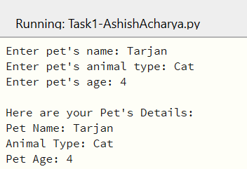

**Task2:**

**Code:**

**import pandas as pd**

**# a. Creating a DataFrame named temperatures from a dictionary of three temperature readings each for three people ’Maxine’, ’James’ and ’Amanda’.**

**data = {'Maxine': [25, 28, 24],**

**'James': [22, 24, 20],**

**'Amanda': [27, 26, 23]}**

**temperatures = pd.DataFrame(data)**

**# b. Recreate the DataFrame temperatures in Part (a) with custom indices using the index keyword argument and a list containing ’Morning’, ’Afternoon’ and ’Evening’.**

**custom_indices = ['Morning', 'Afternoon', 'Evening']**

**temperatures_custom_index = pd.DataFrame(data, index=custom_indices)**

**# c. Select from temperatures the column of temperature readings for ’Maxine’.**

**maxine_temperatures = temperatures['Maxine']**

**# d. Select from temperatures the row of ’Morning’ temperature readings.**

**morning_temperatures = temperatures_custom_index.loc['Morning']**

**# e. Select from temperatures the rows for ’Morning’ and ’Evening’ temperature readings.**

**morning_evening_temperatures = temperatures_custom_index.loc[['Morning', 'Evening']]**

**# f. Select from temperatures the columns of temperature readings for ’Amanda’ and ’Maxine’.**

**amanda_maxine_temperatures = temperatures_custom_index[['Amanda', 'Maxine']]**

**# g. Select from temperatures the elements for ’Amanda’ and ’Maxine’ in the ’Morning’ and ’Afternoon’**

**amanda_maxine_morning_afternoon = temperatures_custom_index.loc[['Morning', 'Afternoon'], ['Amanda', 'Maxine']]**

**# h. Use the describe() method to produce temperatures’ descriptive statistics**

**temperatures_describe = temperatures_custom_index.describe()**

**# i. Transpose the temperatures**

**temperatures_transposed = temperatures_custom_index.transpose()**

**# j. Sort temperatures so that its column names are in alphabetical order.**

**temperatures_sorted = temperatures_custom_index.sort_index(axis=1)**

**# Print the results**

**print("(a) DataFrame temperatures:")**

**print()**

**print(temperatures)**

**print("\n(b) DataFrame temperatures with custom indices:")**

**print(temperatures_custom_index)**

**print("\n(c) Maxine's temperatures:")**

**print(maxine_temperatures)**

**print("\n(d) Morning temperatures:")**

**print(morning_temperatures)**

**print("\n(e) Morning and Evening temperatures:")**

**print(morning_evening_temperatures)**

**print("\n(f) Amanda and Maxine's temperatures:")**

**print(amanda_maxine_temperatures)**

**print("\n(g) Amanda and Maxine's Morning & Afternoon temperatures:")**

**print(amanda_maxine_morning_afternoon)**

**print("\n(h) Descriptive statistics for temperatures:")**

**print(temperatures_describe)**

**print("\n(i) Transposed temperatures:")**

**print(temperatures_transposed)**

**print("\n(j) Sorted temperatures:")**

**print(temperatures_sorted)**

**Output:**

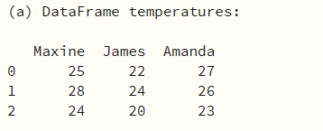

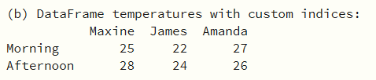

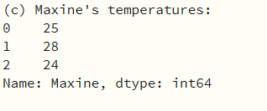

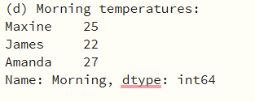

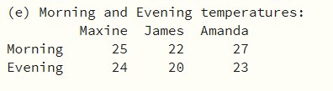

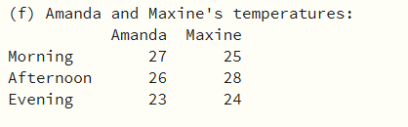

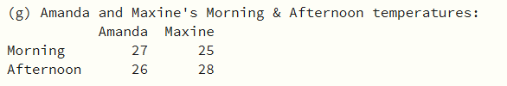

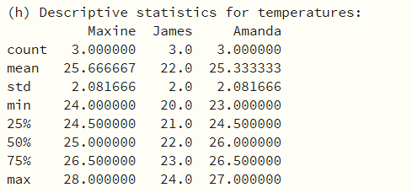

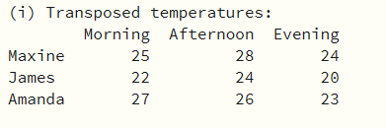

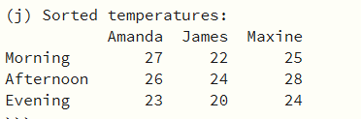

**Task3:**

**Code:**

**import matplotlib.pyplot as plt**

**from sklearn.datasets import load_digits**

**from sklearn.model_selection import train_test_split**

**# Load the Digits dataset**

**digits = load_digits()**

**# Task (a): Display the two-dimensional array and numeric value of the digit at index 35**

**sample_image = digits.images[35]**

**target_value = digits.target[35]**

**print("Sample Image:")**

**print(sample_image)**

**print("Target Value:", target_value)**

**# Task (b): Display the image at index 35 of the Digits dataset**

**plt.imshow(sample_image, cmap='gray')**

**plt.title(f"Sample Image at Index 35 (Digit {target_value})")**

**plt.show()**

**# Task (c): Train-test split and numbers of training/testing samples**

**X_train, X_test, y_train, y_test = train_test_split(**

**digits.data, digits.target, random_state=11, test_size=0.70**

**)**

**num_train_samples = len(X_train)**

**num_test_samples = len(X_test)**

**print("Number of Training Samples:", num_train_samples)**

**print("Number of Testing Samples:", num_test_samples)**

**# Task (d): Display the number of training examples and testing examples**

**print("Number of Training Examples:", num_train_samples)**

**print("Number of Testing Examples:", num_test_samples)**

**# Task (e): Rewrite the list comprehension using a for loop**

**predicted_values = [1, 2, 3, 4, 5, 6, 7, 8, 9, 0]**

**expected_values = [1, 2, 3, 4, 5, 6, 7, 8, 9, 1]**

**wrong_predictions = []**

**for predicted, expected in zip(predicted_values, expected_values):**

**if predicted != expected:**

**wrong_predictions.append((predicted, expected))**

**# Task (f): Explanation for row 3 of the confusion matrix**

**confusion_row_values = [10, 5, 120, 0, 3, 2, 0, 1, 8, 1]**

**print("Explanation for confusion matrix row 3:")**

**for i, count in enumerate(confusion_row_values):**

**print(f"Predicted as {i}: {count} times")**

**Output:**

